**Census Report**

This report contains information about the mock census of an imaginary modest town. To decide what to do with an empty plot of land and what to invest in, this census compares various people throughout the town as well as demographic figures. The data has already been cleaned and analysed, hence this report.

Before any recommendations could be made, the census data had to be cleaned to remove errors and omissions, as explained in the study's first part. This report will subsequently highlight the significant analyses that were conducted with the purpose of supporting the suggestions and recommendations made. A summary of the town’s population demographics is initially presented, followed by a thorough study of the expected population growth, occupation trends, commuters and occupancy rates.

**Data Cleaning**

The data has undergone a process of fixing and removing inconsistent information, fixing the structural errors, filtering out outliers, incorrect formats, duplicates, incomplete data within a set. A column called “unnamed” was firstly dropped since it contained the numbers which is more of a duplicate of the index of the data.

The distinct values have been checked for each column like Gender, Religion, Marital Status, and Infirmity. Inconsistent values were identified in some of the columns and modifications were made. Empty strings were replaced with the values with greatest occurring values while certain values were altered to fit the data set.

A separate column was created for the Occupation column to distinguish between the values stated in the occupation such as employed, jobless, retired, students, and university students. Also floats in the Age column were changed to integers to make the data consistent.

A particular household shows a married 15-year-old as Head of house as well as being a student whereas another household shows a Divorced 17 years old female who is also a student in the instance of marital status. These values are contradictory, indicating either blatant lying or a potentially illicit relationship. No marriage of a person under the age of 21 was valid without the consent of parents or guardians (UK Parliament, 2022).

Relationship to Head of House also revealed outliers, with two females who are "Head" and another man who is "Head" who is only three years old. According to the information provided, only those who are 18 years and older can be head of house.

**Population Pyramid**

The demographic pyramid shows a higher population of middle-aged people, particularly in the age ranges 20–24 and 40–44, which indicates that there is a strong likelihood that the population will continue to expand because these ages groups are of the childbearing years.

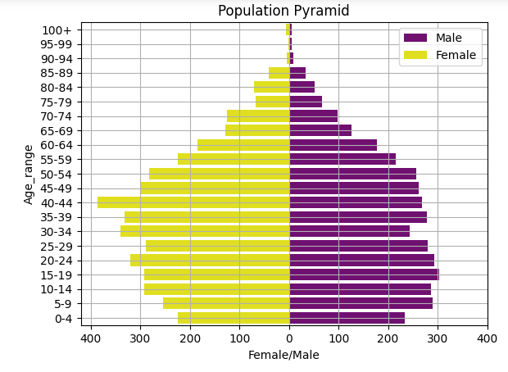

The population pyramid also reveals that there are more women in their middle years. Population reductions in older age groups indicate a less number of elderly persons.

**Occupation Category**

People who are identified as having a specific employment position have been classified as employed in the occupation category, PhD students have been classified as university students, but the student, retired, unemployed, and child categories have been left alone.

The retired individuals are over 65 years old and unemployed, although they cannot be labeled as "Unemployed" because not all unemployed people are aged persons, so these values have been split

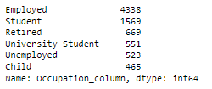

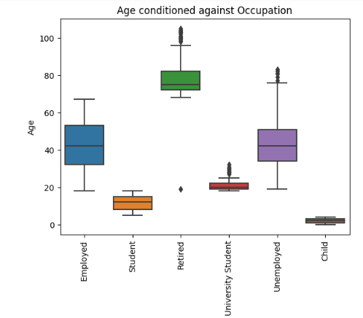

Employed persons outnumber all other occupational status categories in the occupation category by a wide margin, with students coming in second.

This plot demonstrates that those who are employed are between the ages of 20 and 60, but not older than 65. This shows an economically active population.

In order to compute the unemployment rate, the total number of jobless persons in the population was divided by the entire population, and the resulting figure was multiplied by 100. The predicted unemployment rate in the aforementioned census is 6.4%, which is fairly high. This is primarily because the municipality does not have enough activity to encourage employment creation. To create space for new jobs, the community must undergo some kind of industry.

**Marital Status Analysis**

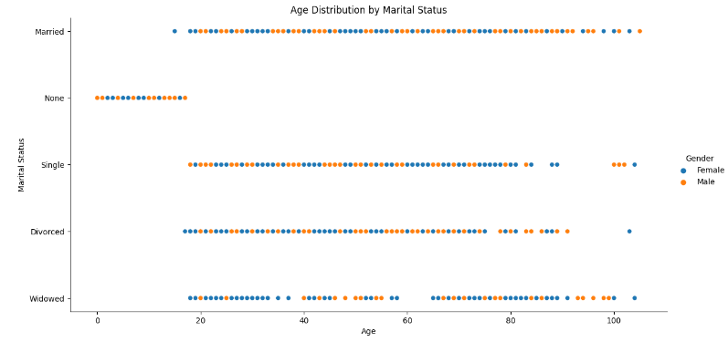

While looking for discrepancies in the population's Marital Status, a variety of factors were found. There were some minors who declared themselves to be married; these are regarded as outliers since they may be engaging in relationships that are unlawful or lying outright. “A person commits an offence under the law of England and Wales if he or she carries out any conduct for the purpose of causing a child to enter a marriage before the child’s eighteenth birthday” (Ministry of Justice and Lord Bellamy, 2022) .

The census also reveals that there are more single persons than married people, as well as a sizable number of N/A values which indicates that they are minors.

**Summary Report**

This data set summary illustrates all of the unique values for each category under a specific column. The important categories were already discussed in the paragraph above, which stated the obvious truths in light of the data provided.

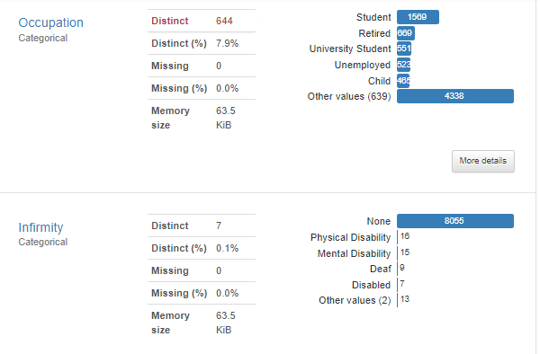

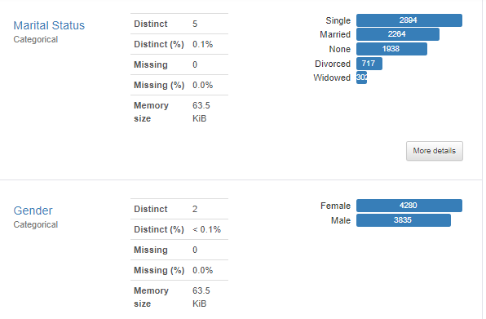

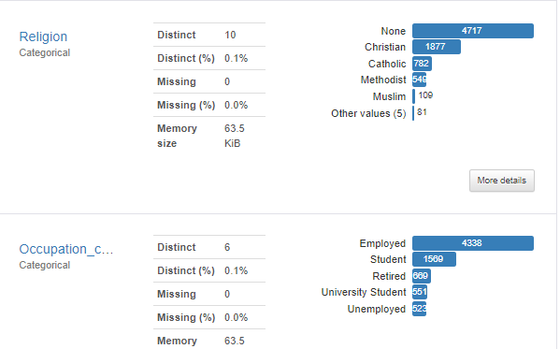

Given the high proportion of singles and married people in the census, there is a likelihood that many more people will marry and those who are already married will have more children, which will lead to a high rate of reproduction and a rise in the population in the future.

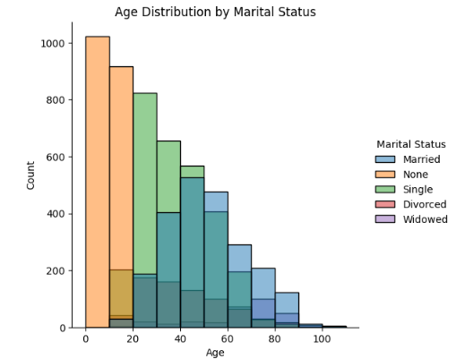

**Religion Analysis**

Religion Affinity displays a very significantly higher percentage of None values, indicating that the majority of the population is non - religious. Although a larger part of those who answered none are underage and are therefore unable to specify.

“Parents have the right to choose whether their child follows a religion at home and school, and, if so, which one.” (Citizens advice, 2022).

However, children or young people may choose their preferred religion based on their level of understanding.

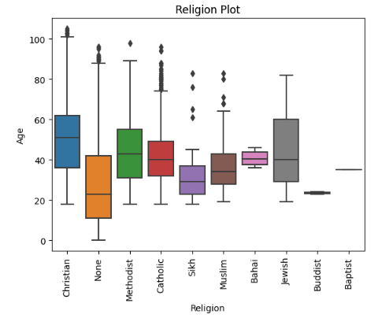

Christianity is the second dominant value which includes various denominations but is still divided because each one practices religion in a unique way that highlights a big difference. There is really no indication that the number of adherents to other religions, which are quite few, is expanding.

**Infirmity Analysis**

Given that a significant portion of respondents to the census chose None, the percentage of disability is extremely low. Because of this, there are more healthy individuals.

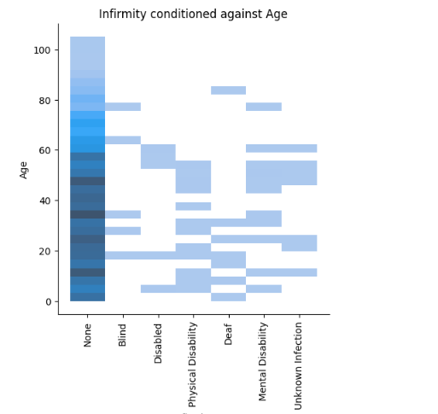

**Calculating the Birth Rate and Death Rate**

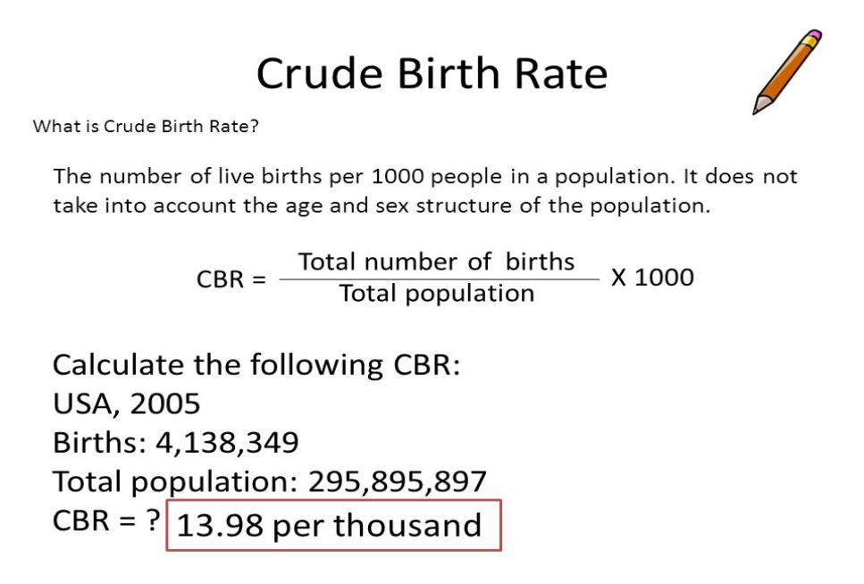

The number of live births per 1000 people in a particular population each year is used to calculate the crude birth rate (United Nations, Department of Economic and Social Affairs, 2013). The total population is divided by the number of live births recorded at the census, and the resulting number is then multiplied by 1,000.

The expected number of live births in this census is 91, and the estimated birth rate overall is 11.2 (rounded to 11). This is a sign that there are fewer babies being born, which causes immigration to rise, the workforce to be smaller, and the population to age.

The number of deaths in a particular population per year is divided by the population size, and the result is then multiplied by 1,000 to get the crude mortality rate. The death rate was calculated by estimating the difference in each age group of five years; the result was divided by the total population multiplied by 1,000, which is estimated to be 1.4 but rounded to 1.

However, the death data for this census was not provided, hence the death rate was calculated by estimating the difference in each age group of five years. The result is divided by the total population multiplied by 1,000 which is estimated to be 1.4 but rounded to 1. This signifies a low mortality rate.

The population growth rate is estimated to be 9.7 per thousand in a year. This is derived by the difference in birth rate and death rate. Falling birth rates and death rates means a final stability where both birth rate and death rate are declining. Population growth continues due to the large number of people in the reproductive age group.

As highlighted previously, the Marital Status in the given census shows a high rate of single and married population signifying that there's a possibility of many more people getting married and the already existing married people having more children which will in turn result in high rate of reproduction thereby leading to an increase in the population in future. Reproductive age group refers to women within the age range of 15-45 years (GOV.UK, 2022).

Although the birth rate per thousand is quite low and the death rate per thousand is significantly lower, it still means that the population records more births than deaths.

**OCCUPANY RATE**

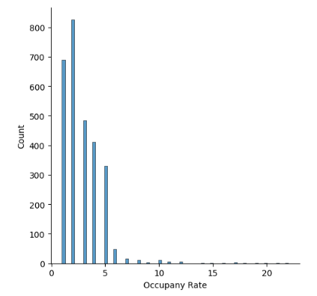

The occupancy rate displays the proportion of occupied rooms to all available rooms in a household. The plot demonstrates that the occupancy rate is primarily greater for households with 1 to 5 occupants, while it is generally lower for households with 5 occupants or more. This demonstrates that there isn't necessarily any type of overpopulation ensuring convenience inside the household. The households with greater occupancy rates may have lodgers, and some homes may be large enough to support the large number of occupants. In some other cases, it could be a case of overcrowding within a dwelling.

**Number of Commuters**

Given that there is no university located within the town and that all university students commute from the town to other locations where universities are located, the number of commuters was calculated by adding the population's total employed individuals and the number of university students. Although not all of the employed population will commute, it is predicted that a sizable portion of them tend to leave the city for work. The estimation was also made assuming everyone within the town will possibly commute because it is in between two large cities, hence people will want to commute for various other reasons.

Since it is assumed that more than half of the population commutes, the municipality needs to construct a train station. People will undoubtedly travel to the town because it is situated between two major cities for a variety of reasons, including going to see relatives, shopping, working, and so many other things.

**Marriage and Divorce Rate**

To calculate the marriage rate, the population's total number of married individuals was divided by two, and the resulting number was then divided by total population and multiplied by 1000 to estimate the marriage rate. According to the data from the census, there were 139 marriages for every 1,000 people, which is a high rate of marriages per thousand people per year. This is already demonstrated by the overall percentage of people in the census who identify as married, which is much higher than the percentage for those with other marital statuses except those who are single. A high marriage rate indicates future population growth, although this is not yet confirmed and is open to further analysis.

Similar methods are used to calculate the divorce rate as well. To obtain the estimated divorce rate, the total number of people who identify as divorced is divided by two, multiplied by the population as a whole, and the result is multiplied by 1000. According to this census, the predicted overall divorce rate is 44 per 1,000 people, which is quite low when compared to the marriage rate. In the following section of this report, housing decisions will be made utilising this outcome.

**Recommendations:**

There will be a need for high density housing to accommodate more families and provide room for future generations due to the growing population, which is demonstrated by the high number of people who identify as married as well as the estimated growing rate of marriages. Given that people tend to have children within marriages and that those who are already married may decide to have children or give birth to more children, a high rate of marriage suggests that fertility may be high.

The number of commuters has already been calculated by include both the local workforce and college students. Having a train station will make it easier for residents to travel to and from the town, and it will also draw more visitors from nearby cities and towns, which will boost the local economy.

Since a sizable portion of the population chose None, there is no need to construct a religious centre. The second most prevalent value is Christianity, which has many different denominations. However, because there is already a Catholic church in the town, the other denominations will need different buildings for each of them since they do not all worship under the same roof.

There is little evidence of widespread injuries and there is a low prevalence of disability, it may not be necessary to construct an emergency medical facility. However, given the rising number of marriages and the potential population growth, a full hospital should be taken into consideration in the future.

The town's economy needs to be strengthened because, as was already mentioned, the unemployment rate is fairly high. To do this, it is necessary to create jobs, retrain residents in new skills, and generally invest in infrastructure that will draw investors and strengthen the town's economy. The train station will serve as a major source of employment, so it is important to build one to improve the economy of the town as well

It will be necessary to set aside money for end-of-life care. Although the number of retirees and the rate of infirmity are both relatively modest in the current census, this may not be the case in the future.

**Bibliography**

Citizens Advice (2022) Young People’s Rights. Available online at: <https://www.citizensadvice.org.uk/law-and-courts/civil-rights/young-people-s-rights/> (Accessed on: December 8, 2022)

Economic and Social Affairs, Population Division (2013). World Population Ageing 2013. *United Nations*. Available online at: <https://www.un.org/en/development/desa/population/publications/pdf/ageing/WorldPopulationAgeing2013.pdf> (Accessed on: December 7, 2022)

Ministry of Justice and Lord Bellamy KC (2022) Implementation of the Marriage and Civil Partnership (Minimum Age) Act 2022. *GOV.UK*. Available online at: <https://www.gov.uk/government/news/implementation-of-the-marriage-and-civil-partnership-minimum-age-act-2022> (Accessed on: December 8, 2022).

UK Parliament (2022) The Law of Marriage. Available online at: <https://www.parliament.uk/about/living-heritage/transformingsociety/private-lives/relationships/overview/lawofmarriage-/> (Accessed on: December 7, 2022)

World Fertility Data 2012 (POP/DB/Fert/Rev2012).

**<https://www.ncbi.nlm.nih.gov/books/NBK535289/>**